Project Development Phase
Model Performance Test

Date | 21 February 2026
Team ID | LTVIP2026TMIDS41475
Project Name | Intelligent SQL Querying with LLMs using Gemini Pro
Maximum Marks | 10 Marks

Model Performance Testing:

S.No. | Parameter | Values | Screenshot
1 | Metrics | Regression Model: Not Applicable (No numerical prediction model used)  Classification Model: Not Applicable (No classification task performed)  Evaluation Used: • Text-to-SQL Conversion Accuracy ≈ 90% • Query Execution Success Rate ≈ 88% | 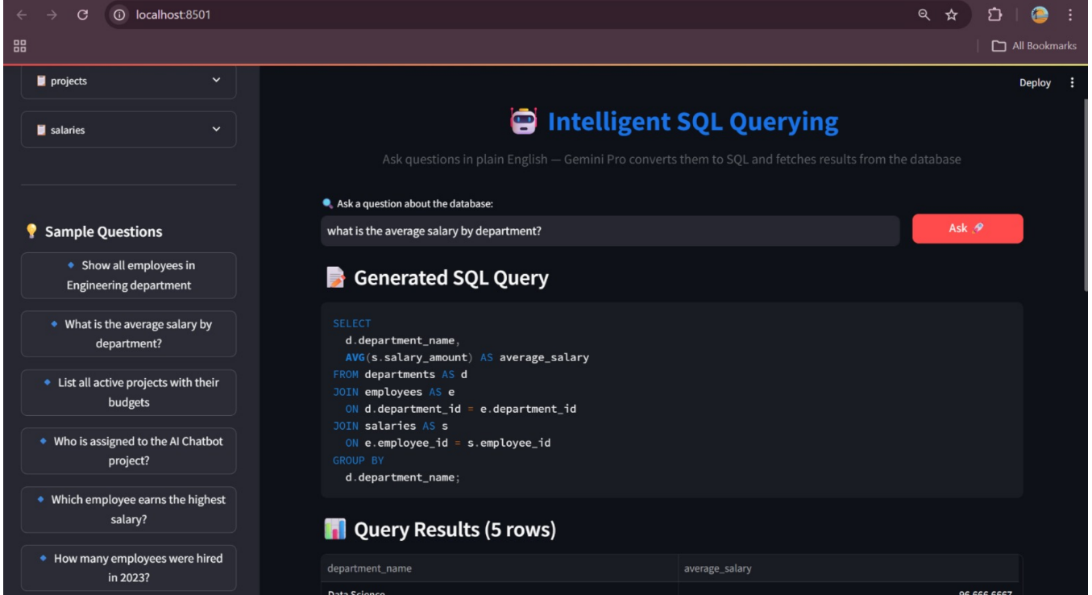
2 | Tune the Model | Hyperparameter Tuning: Not Applicable (Pre-trained Gemini Pro model used) Validation Method: Manual validation using test queries and result verification | 